3.3 REGULATED POWER SUPPLY:
3.3.1 Introduction:
Power supply is a supply of electrical power. A device or system that supplies electrical or other types of energy to an output load or group of loads is called a power supply unit or PSU. The term is most commonly applied to electrical energy supplies, less often to mechanical ones, and rarely to others.
A power supply may include a power distribution system as well as primary or secondary sources of energy such as
- Conversion of one form of electrical power to another desired form and voltage, typically involving converting AC line voltage to a well-regulated lower-voltage DC for electronic devices. Low voltage, low power DC power supply units are commonly integrated with the devices they supply, such as computers and household electronics.
- Batteries.
- Chemical fuel cells and other forms of energy storage systems.
- Solar power.
- Generators or alternators.

3.3.2 Block Diagram:

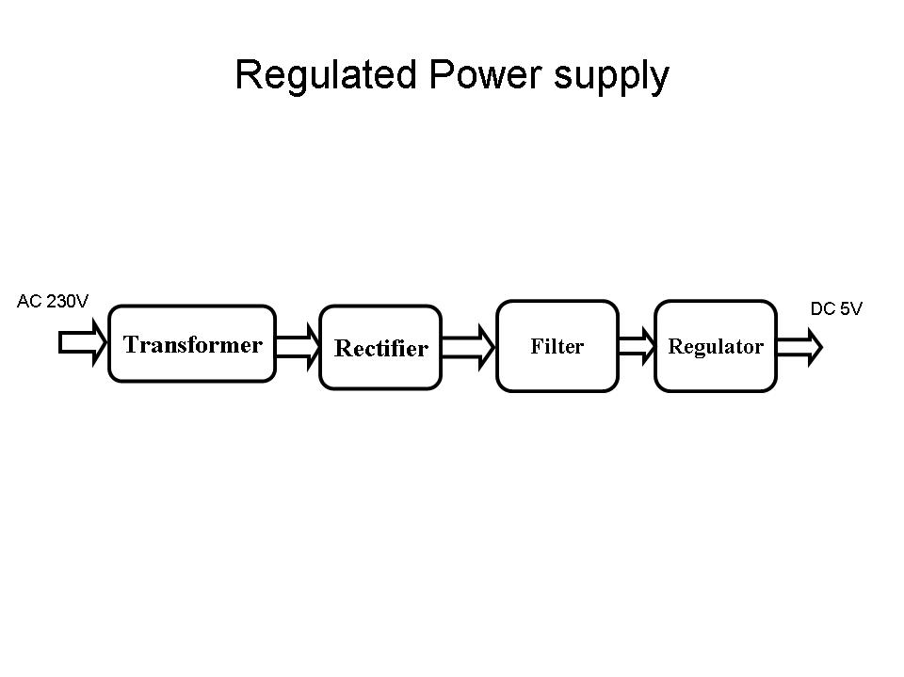
Fig 3.3.2 Regulated Power Supply
The basic circuit diagram of a regulated power supply (DC O/P) with led connected as load is shown below
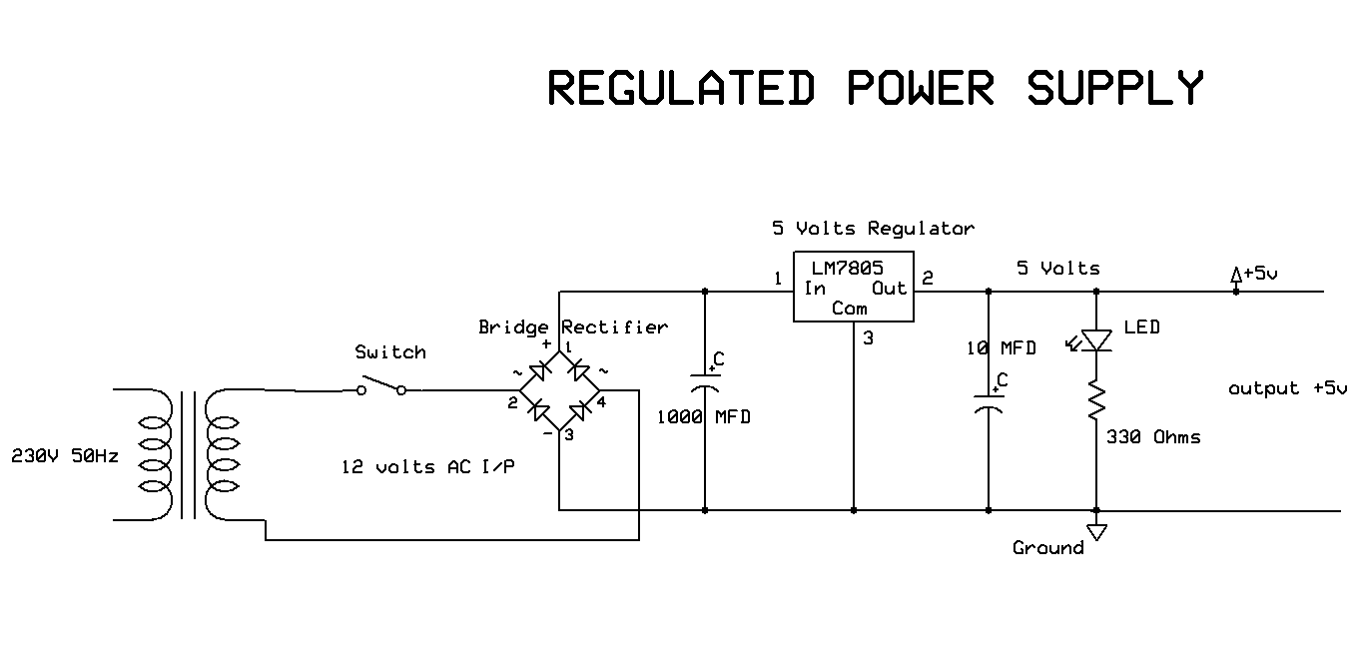
Fig 3.3.3 Circuit diagram of Regulated Power Supply with Led connection

The components mainly used in above figure are
- 230V AC MAINS
- TRANSFORMER
- BRIDGE RECTIFIER(DIODES)
- CAPACITOR
- VOLTAGE REGULATOR(IC 7805)
- RESISTOR
- LED(LIGHT EMITTING DIODE)

POWER SUPPLY DESIGN:

Input is 230 volts A.C
Transformation
Rectification
Filtration
Regulation
Output is 5 volts D.C

The detailed explanation of each and every block and component mentioned above is as follows:

- Transformation:
The process of transforming energy from one device to another is called transformation. For transforming energy we use transformers.

Transformers:
A transformer is a device that transfers electrical energy from one circuit to another through inductively coupled conductors without changing its frequency. A varying current in the first or primary winding creates a varying magnetic flux in the transformer's core, and thus a varying magnetic field through the secondary winding. This varying magnetic field induces a varying electromotive force (EMF) or "voltage" in the secondary winding. This effect is called mutual induction.
If a load is connected to the secondary, an electric current will flow in the secondary winding and electrical energy will be transferred from the primary circuit through the transformer to the load. This field is made up from lines of force and has the same shape as a bar magnet.
If the current is increased, the lines of force move outwards from the coil. If the current is reduced, the lines of force move inwards.
If another coil is placed adjacent to the first coil then, as the field moves out or in, the moving lines of force will "cut" the turns of the second coil. As it does this, a voltage is induced in the second coil. With the 50 Hz AC mains supply, this will happen 50 times a second. This is called MUTUAL INDUCTION and forms the basis of the transformer.
The input coil is called the PRIMARY WINDING; the output coil is the SECONDARY WINDING. Fig: 3.5 shows step-down transformer.
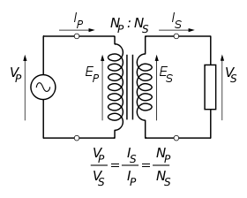
Fig 3.4: Step-Down Transformer
The voltage induced in the secondary is determined by the TURNS RATIO.
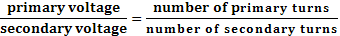
For example, if the secondary has half the primary turns; the secondary will have half the primary voltage.
Another example is if the primary has 5000 turns and the secondary has 500 turns, then the turn’s ratio is 10:1.
If the primary voltage is 240 volts then the secondary voltage will be x 10 smaller = 24 volts. Assuming a perfect transformer, the power provided by the primary must equal the power taken by a load on the secondary. If a 24-watt lamp is connected across a 24 volt secondary, then the primary must supply 24 watts.
To aid magnetic coupling between primary and secondary, the coils are wound on a metal CORE. Since the primary would induce power, called EDDY CURRENTS, into this core, the core is LAMINATED. This means that it is made up from metal sheets insulated from each other. Transformers to work at higher frequencies have an iron dust core or no core at all.
Note that the transformer only works on AC, which has a constantly changing current and moving field. DC has a steady current and therefore a steady field and there would be no induction.
Some transformers have an electrostatic screen between primary and secondary. This is to prevent some types of interference being fed from the equipment down into the mains supply, or in the other direction. Transformers are sometimes used for IMPEDANCE MATCHING.
We can use the transformers as step up or step down.
Step Up transformer:
In case of step up transformer, primary windings are every less compared to secondary winding.
Because of having more turns secondary winding accepts more energy, and it releases more voltage at the output side.

Step down transformer:
Incase of step down transformer, Primary winding induces more flux than the secondary winding, and secondary winding is having less number of turns because of that it accepts less number of flux, and releases less amount of voltage.
Battery power supply:
A battery is a type of linear power supply that offers benefits that traditional line-operated power supplies lack: mobility, portability and reliability. A battery consists of multiple electrochemical cells connected to provide the voltage desired. Fig: 3.6 shows Hi-Watt 9V battery
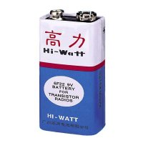
Fig 3.5: Hi-Watt 9V Battery
The most commonly used dry-cell battery is the carbon-zinc dry cell battery. Dry-cell batteries are made by stacking a carbon plate, a layer of electrolyte paste, and a zinc plate alternately until the desired total voltage is achieved. The most common dry-cell batteries have one of the following voltages: 1.5, 3, 6, 9, 22.5, 45, and 90. During the discharge of a carbon-zinc battery, the zinc metal is converted to a zinc salt in the electrolyte, and magnesium dioxide is reduced at the carbon electrode. These actions establish a voltage of approximately 1.5 V.
The lead-acid storage battery may be used. This battery is rechargeable; it consists of lead and lead/dioxide electrodes which are immersed in sulfuric acid. When fully charged, this type of battery has a 2.06-2.14 V potential (A 12 volt car battery uses 6 cells in series). During discharge, the lead is converted to lead sulfate and the sulfuric acid is converted to water. When the battery is charging, the lead sulfate is converted back to lead and lead dioxide A nickel-cadmium battery has become more popular in recent years. This battery cell is completely sealed and rechargeable. The electrolyte is not involved in the electrode reaction, making the voltage constant over the span of the batteries long service life. During the charging process, nickel oxide is oxidized to its higher oxidation state and cadmium oxide is reduced. The nickel-cadmium batteries have many benefits. They can be stored both charged and uncharged. They have a long service life, high current availabilities, constant voltage, and the ability to be recharged.
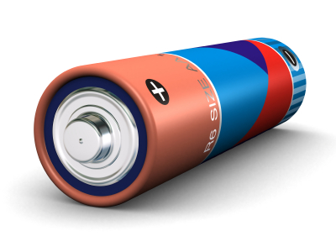
Fig 3.6: Pencil Battery of 1.5V
2. Rectification:
The process of converting an alternating current to a pulsating direct current is called as rectification. For rectification purpose we use rectifiers.
Rectifiers:
A rectifier is an electrical device that converts alternating current (AC) to direct current (DC), a process known as rectification. Rectifiers have many uses including as components of power supplies and as detectors of radio signals. Rectifiers may be made of solid-state diodes, vacuum tube diodes, mercury arc valves, and other components.
A device that it can perform the opposite function (converting DC to AC) is known as an inverter.
When only one diode is used to rectify AC (by blocking the negative or positive portion of the waveform), the difference between the term diode and the term rectifier is merely one of usage, i.e., the term rectifier describes a diode that is being used to convert AC to DC. Almost all rectifiers comprise a number of diodes in a specific arrangement for more efficiently converting AC to DC than is possible with only one diode. Before the development of silicon semiconductor rectifiers, vacuum tube diodes and copper (I) oxide or selenium rectifier stacks were used.
Bridge full wave rectifier:
The Bridge rectifier circuit is shown in fig:3.8, which converts an ac voltage to dc voltage using both half cycles of the input ac voltage. The Bridge rectifier circuit is shown in the figure. The circuit has four diodes connected to form a bridge. The ac input voltage is applied to the diagonally opposite ends of the bridge. The load resistance is connected between the other two ends of the bridge.
For the positive half cycle of the input ac voltage, diodes D1 and D3 conduct, whereas diodes D2 and D4 remain in the OFF state. The conducting diodes will be in series with the load resistance R_{L} and hence the load current flows through R_{L.}
For the negative half cycle of the input ac voltage, diodes D2 and D4 conduct whereas, D1 and D3 remain OFF. The conducting diodes D2 and D4 will be in series with the load resistance R_{L} and hence the current flows through R_{L} in the same direction as in the previous half cycle. Thus a bi-directional wave is converted into a unidirectional wave.

Input Output
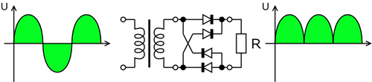

Fig 3.7: Bridge rectifier: a full-wave rectifier using 4 diodes

DB107:
Now -a -days Bridge rectifier is available in IC with a number of DB107. In our project we are using an IC in place of bridge rectifier. The picture of DB 107 is shown below
Features:
- Good for automation insertion
- Surge overload rating - 30 amperes peak
- Ideal for printed circuit board
- Reliable low cost construction utilizing molded
- Glass passivated device
- Polarity symbols molded on body
- Mounting position: Any
- Weight: 1.0 gram
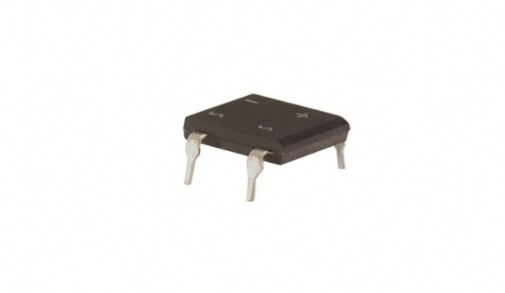
Fig 3.8: DB107
3. Filtration:
The process of converting a pulsating direct current to a pure direct current using filters is called as filtration.

Filters:
Electronic filters are electronic circuits, which perform signal-processing functions, specifically to remove unwanted frequency components from the signal, to enhance wanted ones.
Introduction to Capacitors:
The Capacitor or sometimes referred to as a Condenser is a passive device, and one which stores energy in the form of an electrostatic field which produces a potential (static voltage) across its plates. In its basic form a capacitor consists of two parallel conductive plates that are not connected but are electrically separated either by air or by an insulating material called the Dielectric. When a voltage is applied to these plates, a current flows charging up the plates with electrons giving one plate a positive charge and the other plate an equal and opposite negative charge. This flow of electrons to the plates is known as the Charging Current and continues to flow until the voltage across the plates (and hence the capacitor) is equal to the applied voltage Vcc. At this point the capacitor is said to be fully charged and this is illustrated below. The construction of capacitor and an electrolytic capacitor are shown in figures 3.10 and 3.11 respectively.
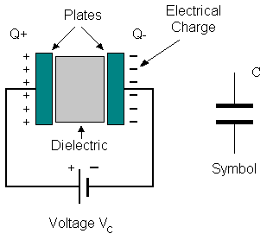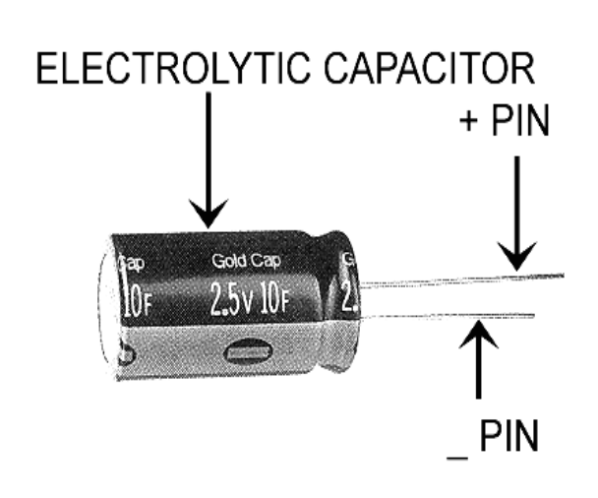
Fig 3.9:Construction Of a Capacitor Fig 3.10:Electrolytic Capaticor
Units of Capacitance:
Microfarad (μF) 1μF = 1/1,000,000 = 0.000001 = 10⁻⁶ F
Nanofarad (nF) 1nF = 1/1,000,000,000 = 0.000000001 = 10⁻⁹ F
Pico farad (pF) 1pF = 1/1,000,000,000,000 = 0.000000000001 = 10⁻¹² F

Operation of Capacitor:
Think of water flowing through a pipe. If we imagine a capacitor as being a storage tank with an inlet and an outlet pipe, it is possible to show approximately how an electronic capacitor works.
First, let's consider the case of a "coupling capacitor" where the capacitor is used to connect a signal from one part of a circuit to another but without allowing any direct current to flow.
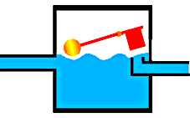 | If the current flow is alternating between zero and a maximum, our "storage tank" capacitor will allow the current waves to pass through.
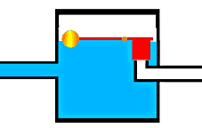 | However, if there is a steady current, only the initial short burst will flow until the "floating ball valve" closes and stops further flow.
So a coupling capacitor allows "alternating current" to pass through because the ball valve doesn't get a chance to close as the waves go up and down. However, a steady current quickly fills the tank so that all flow stops.
A capacitor will pass alternating current but (apart from an initial surge) it will not pass d.c.
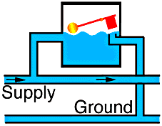 | Where a capacitor is used to decouple a circuit, the effect is to "smooth out ripples". Any ripples, waves or pulses of current are passed to ground while d.c. Flows smoothly.
4. Regulation:
The process of converting a varying voltage to a constant regulated voltage is called as regulation. For the process of regulation we use voltage regulators.
Voltage Regulator:
A voltage regulator (also called a ‘regulator’) with only three terminals appears to be a simple device, but it is in fact a very complex integrated circuit. It converts a varying input voltage into a constant ‘regulated’ output voltage. Voltage Regulators are available in a variety of outputs like 5V, 6V, 9V, 12V and 15V. The LM78XX series of voltage regulators are designed for positive input. For applications requiring negative input, the LM79XX series is used. Using a pair of ‘voltage-divider’ resistors can increase the output voltage of a regulator circuit.
It is not possible to obtain a voltage lower than the stated rating. You cannot use a 12V regulator to make a 5V power supply. Voltage regulators are very robust. These can withstand over-current draw due to short circuits and also over-heating. In both cases, the regulator will cut off before any damage occurs. The only way to destroy a regulator is to apply reverse voltage to its input. Reverse polarity destroys the regulator almost instantly. Fig: 3.12 shows voltage regulator.
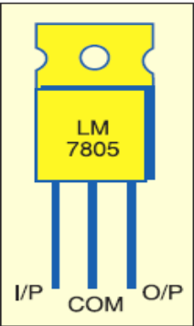
Fig 3.11: Voltage Regulator

Resistors:
A resistor is a two-terminal electronic component that produces a voltage across its terminals that is proportional to the electric current passing through it in accordance with Ohm's law:
V = IR
Resistors are elements of electrical networks and electronic circuits and are ubiquitous in most electronic equipment. Practical resistors can be made of various compounds and films, as well as resistance wire (wire made of a high-resistivity alloy, such as nickel/chrome).
The primary characteristics of a resistor are the resistance, the tolerance, maximum working voltage and the power rating. Other characteristics include temperature coefficient, noise, and inductance. Less well-known is critical resistance, the value below which power dissipation limits the maximum permitted current flow, and above which the limit is applied voltage. Critical resistance is determined by the design, materials and dimensions of the resistor.
Resistors can be made to control the flow of current, to work as Voltage dividers, to dissipate power and it can shape electrical waves when used in combination of other components. Basic unit is ohms.
Theory of operation:

Ohm's law:

The behavior of an ideal resistor is dictated by the relationship specified in Ohm's law:
V = IR
Ohm's law states that the voltage (V) across a resistor is proportional to the current (I) through it where the constant of proportionality is the resistance (R).

Power dissipation:
The power dissipated by a resistor (or the equivalent resistance of a resistor network) is calculated using the following:
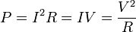
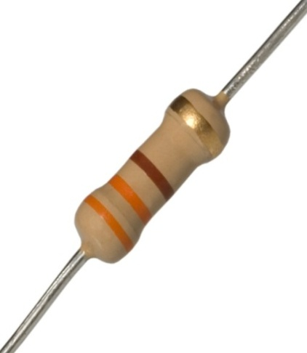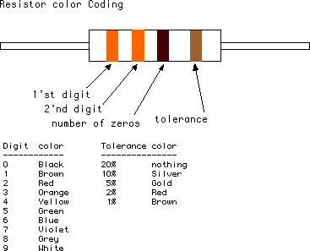
Fig 3.12: Resistor Fig 3.13: Color Bands In Resistor

3.4. LED:
A light-emitting diode (LED) is a semiconductor light source. LED’s are used as indicator lamps in many devices, and are increasingly used for lighting. Introduced as a practical electronic component in 1962, early LED’s emitted low-intensity red light, but modern versions are available across the visible, ultraviolet and infrared wavelengths, with very high brightness. The internal structure and parts of a led are shown in figures 3.15 and 3.16 respectively.
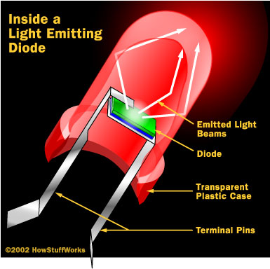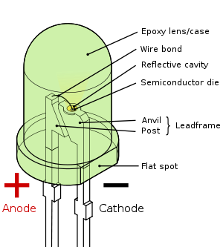
Fig 3.14: Inside a LED Fig 3.15: Parts of a LED

Working:
The structure of the LED light is completely different than that of the light bulb. Amazingly, the LED has a simple and strong structure. The light-emitting semiconductor material is what determines the LED's color. The LED is based on the semiconductor diode.
When a diode is forward biased (switched on), electrons are able to recombine with holes within the device, releasing energy in the form of photons. This effect is called electroluminescence and the color of the light (corresponding to the energy of the photon) is determined by the energy gap of the semiconductor. An LED is usually small in area (less than 1 mm²), and integrated optical components are used to shape its radiation pattern and assist in reflection. LED’s present many advantages over incandescent light sources including lower energy consumption, longer lifetime, improved robustness, smaller size, faster switching, and greater durability and reliability. However, they are relatively expensive and require more precise current and heat management than traditional light sources. Current LED products for general lighting are more expensive to buy than fluorescent lamp sources of comparable output. They also enjoy use in applications as diverse as replacements for traditional light sources in automotive lighting (particularly indicators) and in traffic signals. The compact size of LED’s has allowed new text and video displays and sensors to be developed, while their high switching rates are useful in advanced communications technology. The electrical symbol and polarities of led are shown in fig: 3.17.
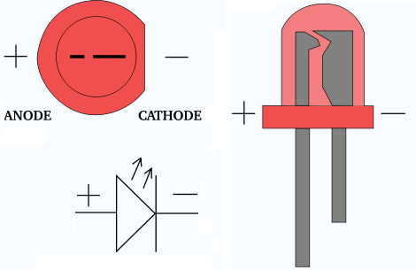
Fig 3.16: Electrical Symbol & Polarities of LED

LED lights have a variety of advantages over other light sources:
- High-levels of brightness and intensity
- High-efficiency
- Low-voltage and current requirements
- Low radiated heat
- High reliability (resistant to shock and vibration)
- No UV Rays
- Long source life
- Can be easily controlled and programmed

Applications of LED fall into three major categories:
- Visual signal application where the light goes more or less directly from the LED to the human eye, to convey a message or meaning.
- Illumination where LED light is reflected from object to give visual response of these objects.
- Generate light for measuring and interacting with processes that do not involve the human visual system.

